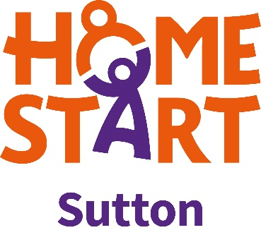

Home-Start Gift Aid Form
Increase your gift for free

If you Gift Aid your donation, Home-Start Sutton will continue to receive an additional
28p on every pound donated. Home-Start Sutton can claim Gift Aid tax relief of 25p on every pound you give. HMRC will also be operating transitional provisions of Gift Aid donation from 6 April 2008 until 5 April 2011, paying a Government supplement of 3p on every pound you give.

Tick all that apply.
I would like to Gift Aid this donation
I would like to Gift Aid all future donations until further notice
I would like to Gift Aid all previous donations for the charity’s current financial period and the previous six
Amount of donation £.....................................

To qualify for Gift Aid, you must pay an amount of UK Income Tax and / or Capital Gains Tax at least equal to the tax that the charity reclaims on your donations in the appropriate tax year (currently 25p for each £1 given). Tax year is 6 April one year to 5 April the next.

Name:_________________________________________

Signature:__________________ Date:_______________

Address:____________________________________________________________

___________________________________________________________________

Thank you so much for supporting Home-Start.
Home-Start – because every child needs a good start and any parent can need support.

- You can cancel this declaration at any time by notifying Home-Start Sutton
- If your circumstances change and you no longer pay enough income or capital gains tax to cover the amount claimed by Home-Start Sutton, you can cancel your declaration
- If you pay tax at the higher rate, you can claim further tax relief via your self assessment tax return (currently 25p for each pound you give)
- Please notify Home-Start Sutton if you change your name or address
- Gift aid is linked to basic rate tax. Basic rate tax is currently 20%, which allows Home-Start Sutton to reclaim 25p in the pound.
- Higher rate taxpayers can claim back the difference between the basic rate and the higher rate tax.

Home-Start Sutton, a company limited by guarantee, Registered in England and Wales no. 5165417, Registered Charity no. 1104960

